Below is a Cedar Capital branding style guide derived directly from what you discussed (warm + human + trustworthy, “bank-grade” colors, earthy palette, friendly-professional typography, and lots of real-life authenticity).

Cedar Capital Brand Style Guide (v1)

Brand intent
Cedar Capital should feel like:
- Trustworthy like a bank (capital, certainty, professionalism)
- Warm like a local family (human, relational, “we’ll actually show up”)
- Modern + streamlined (tech behind the scenes, but never “cold AI”)
A good shorthand: “Local heart + institutional confidence.”

Visual Mood

Color mood words
Earthy • Premium • Calm • Grounded • Warm • Clean • Non-neon

What to avoid
- Neon colors, overly techy gradients, “crypto bro” vibes
- Aggressive red urgency design
- Sterile corporate stock-photo-only look

Color System (Hex)
You mentioned dark green + gold as the core “power colors” (bank/money), with supporting creams/navies.

Primary Colors
Use these most often.
- Cedar Green (Primary Brand)
- #0B3D2E
Deep, grounded, premium. Primary headers, nav, buttons, key accents.
- Capital Gold (Primary Accent)
- #C8A24A
Signals “capital / confidence / premium.” Use for highlights, icons, subtle emphasis, button accents.

Secondary Colors
Support the look without overpowering.
- Evergreen (Secondary Green)
- #1F5B47
For hover states, section backgrounds, secondary buttons, supportive accents.
- Navy Ink (Professional Depth)
- #0F2233
For body text alternatives, footer backgrounds, or when you want “serious + clean” without black.

Neutrals
These keep it warm + readable.
- Cream (Primary Background)
- #F6F1E6
Warm, approachable background to avoid sterile white.
- Sand (Secondary Background / Cards)
- #E9DDC7
For subtle panels, form sections, cards.
- Stone (Borders / Lines / UI Dividers)
- #D2C7B3
- Charcoal (Body Text)
- #1F2933
Primary body text for readability (so you don’t use pure black).

Utility Colors (minimal use)
Keep these muted so the brand stays calm.
- Success: #2F6F55
- Warning: #B07A2A
- Error: #A13A3A
- Info: #2B5C7A

Color Usage Rules (Simple + Practical)

Backgrounds
- Default page background: Cream #F6F1E6
- Section alternation: Cream ↔ Sand #E9DDC7
- Footer / deep sections: Navy Ink #0F2233

Buttons
Primary button
- Background: Cedar Green #0B3D2E
- Text: Cream #F6F1E6
- Hover: Evergreen #1F5B47
- Focus ring: Capital Gold #C8A24A at ~30% opacity (or equivalent)
Secondary button
- Background: transparent
- Border: Cedar Green #0B3D2E
- Text: Cedar Green #0B3D2E
- Hover fill: Sand #E9DDC7
Accent button (sparingly)
- Background: Capital Gold #C8A24A
- Text: Navy Ink #0F2233
- Hover: #B8923D (slightly deeper gold)

Links
- Default: Evergreen #1F5B47
- Hover: Cedar Green #0B3D2E
- Underline on hover for trust/clarity

Typography (Friendly + Professional)
You mentioned Satoshi (rounded, modern, professional-friendly). Since Satoshi isn’t always available everywhere by default, here’s a clean approach:

Recommended Typography Pair (easy to implement)
Headlines: Plus Jakarta Sans (friendly + premium, great for modern brands)
Body: Inter (clean, extremely readable, “professional tech” without feeling cold)
- Headings: Plus Jakarta Sans (600–700 weight)
- Body: Inter (400–500 weight)

Alternative “More Rounded” Option
If you want a more rounded friendly feel (similar spirit to Satoshi):
- Headlines: Manrope (600–700)
- Body: DM Sans (400–500)

Type Scale (Web)
Keep it simple, confident, and readable.
- H1: 44–52px / 700 / tight line-height (1.05–1.15)
- H2: 32–36px / 700
- H3: 24–28px / 600
- Body: 16–18px / 400–500 / line-height 1.5–1.7
- Small text: 13–14px / 400 (avoid going smaller for trust/readability)

Typography Style Rules
- Avoid all-caps for large blocks (feels aggressive).
- Use sentence case headings most of the time (feels human).
- Keep paragraphs short. Trust increases when content is scannable.

Layout + UI Style

Corner radius
- Buttons: 10–14px
- Cards: 16–20px (soft, warm, premium)

Shadows
Subtle only:
- Card shadow: low blur, low opacity (don’t go “SaaS neon”)

Spacing
- Section padding: 72–96px vertical (desktop), 40–56px (mobile)
- Card padding: 20–28px

Imagery + Brand Trust Assets
This is a key part of the strategy you explicitly discussed: real humans, real local presence.

Photo style
- Natural light
- Outdoor/local Austin feel
- Family vibe (dogs/cats okay, tasteful)
- Not overly staged corporate headshots

Avoid
- Overly glossy “investor brochure” stock photography
- AI-generated faces/images as primary brand photos (undermines the “human trust” promise)

Iconography & Illustrations
- Use simple line icons
- Icon color: Cedar Green #0B3D2E or Capital Gold #C8A24A (sparingly)
- Keep icons supportive, not decorative noise

Voice & Microcopy (for the site)
Tone: warm, direct, confident, local.
Example “feel” of copy:
- “Local Austin buyers. Fast, fair offers.”
- “We’re real people. We show up.”
- “No pressure. Clear timelines. Straight answers.”
Avoid:
- Overly corporate (“synergistic capital solutions…”)
- Overly techy (“AI-powered instant valuation engine…” as the headline)
You can mention tech… but as backstage:
- “We use streamlined tools so you don’t deal with hassle.”

Brand Mark Direction (if/when you design a logo)
- A simple cedar tree mark or abstract leaf/branch is on-theme
- Avoid overly detailed seals/crests (can feel fake)
- Use gold as an accent, not the whole logo fill

Quick “Design Recipe” for the Landing Page
If Dan is building this fast, here’s the easiest combo that will look right immediately:
- Background: Cream #F6F1E6
- Nav + key UI: Cedar Green #0B3D2E
- Accents: Gold #C8A24A
- Footer: Navy Ink #0F2233
- Typography: Plus Jakarta Sans + Inter
- Cards: Sand #E9DDC7 with Stone borders #D2C7B3

If you want, I can also output this as:
- a CSS variables block (ready to paste into a project), and/or
- a one-page brand sheet Dan can reference while building.
can you show me actual colors and the example of what this may look like?
Yes — let’s make this visual and tangible, not just conceptual.
Below I’ll show you:
- Actual color swatches (what these colors look like together)
- A realistic landing-page look & feel using those colors
- How it all comes together emotionally (so you can feel if it’s “right”)

1) Cedar Capital — Actual Color Palette (Visual)

Core Palette (What you’ll see 80% of the time)


5
Here’s what these actually feel like together:
- Cedar Green #0B3D2E
→ grounded, money-safe, “we’re serious but not cold”
- Capital Gold #C8A24A
→ premium, trust, subtle wealth (not flashy)
- Cream #F6F1E6
→ warmth, approachability, removes the “corporate chill”
- Navy Ink #0F2233
→ professionalism, footer depth, legal confidence
- Sand #E9DDC7
→ soft structure for cards, forms, sections
This palette is intentionally bank-grade + human — it reads safe to sellers and credible to investors.

2) What the Website Could Look Like (Real Visual References)

Overall Site Vibe (closest real-world feel)
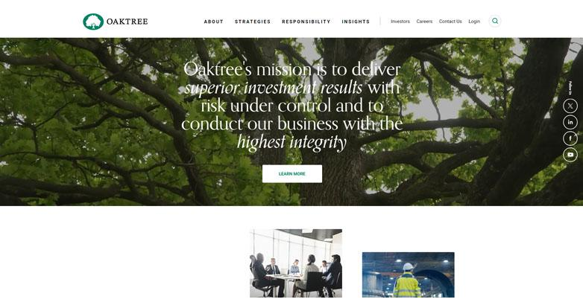
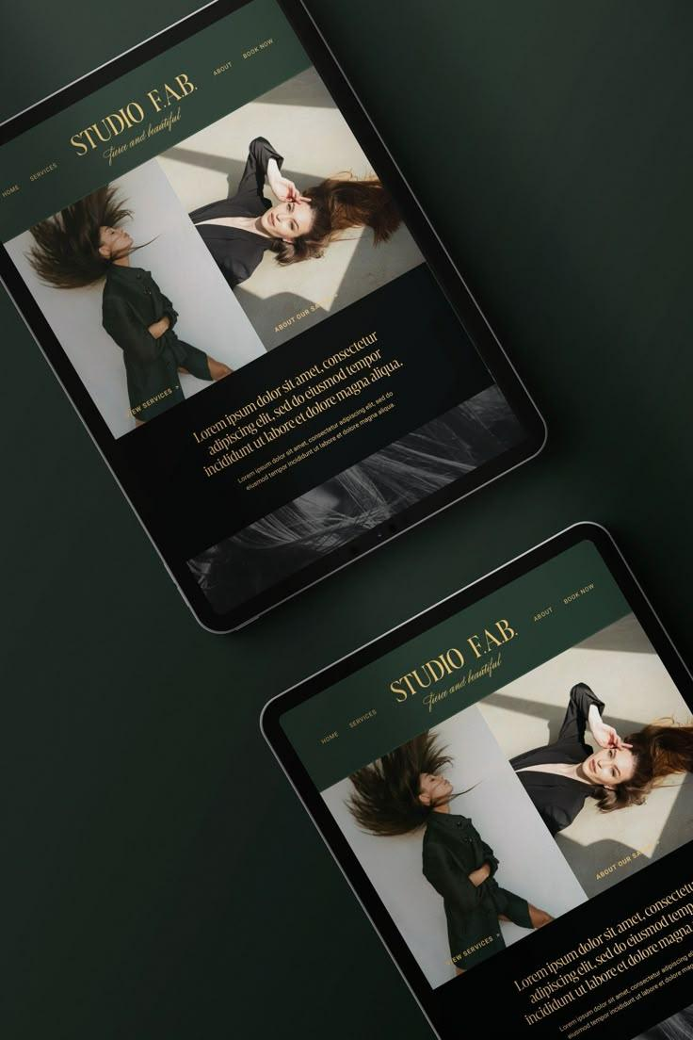

4
Think:
- Soft cream background
- Dark green navigation bar
- Gold accent line or button
- Rounded cards, real photography
- Nothing loud, nothing sharp

3) Example Page Walkthrough (So You Can See It)

Top Navigation (Above the fold)

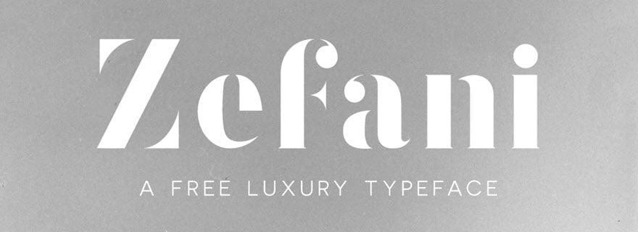
What you’d see:
- Background: Cream
- Logo + nav text: Cedar Green
- CTA button: Cedar Green button with Gold accent
- Typography: friendly, rounded sans-serif (not techy)

Hero Section (First Impression)
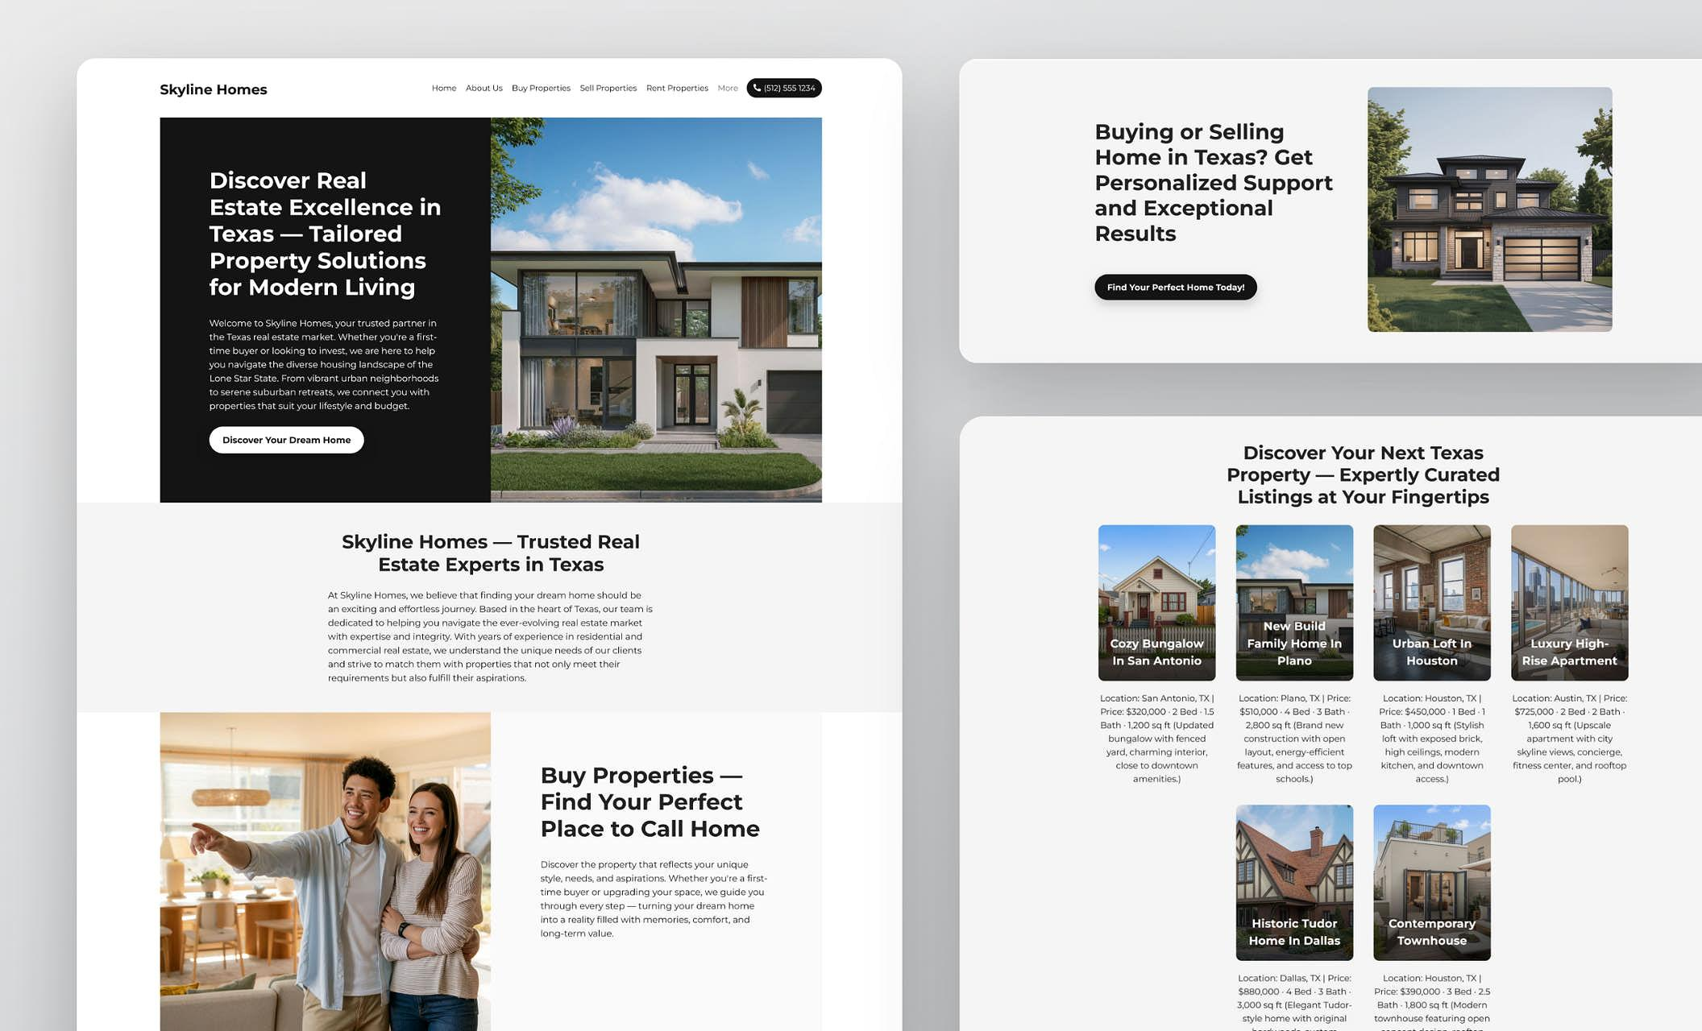
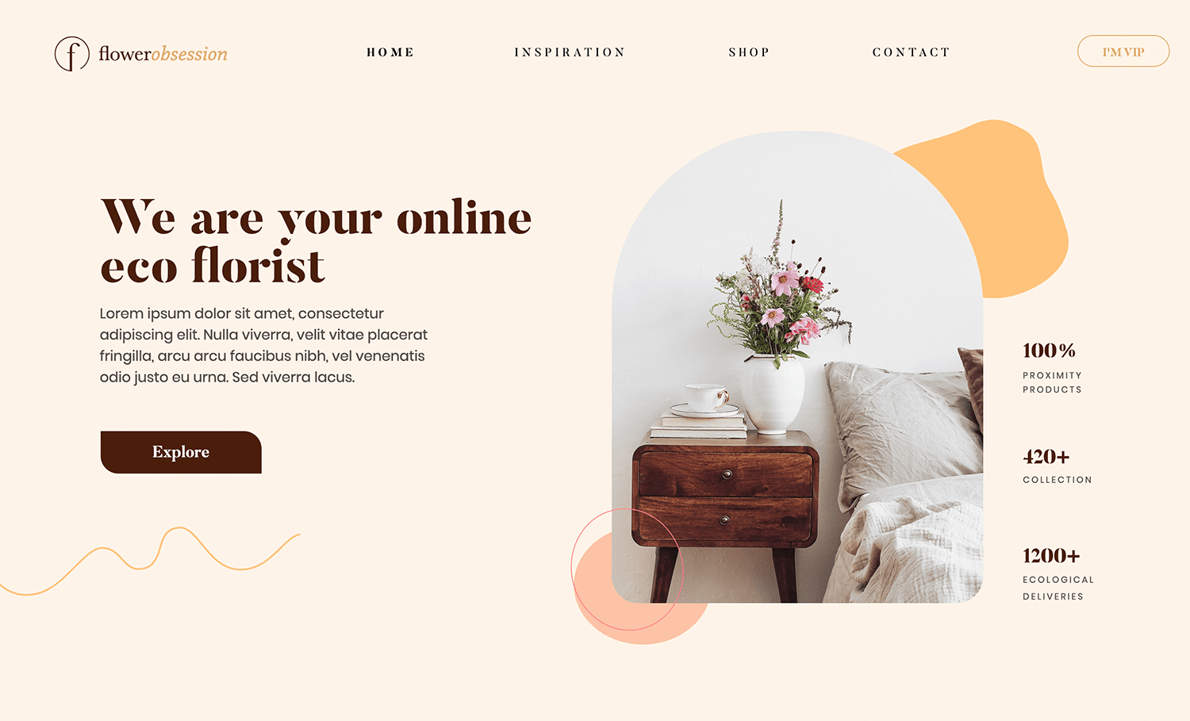
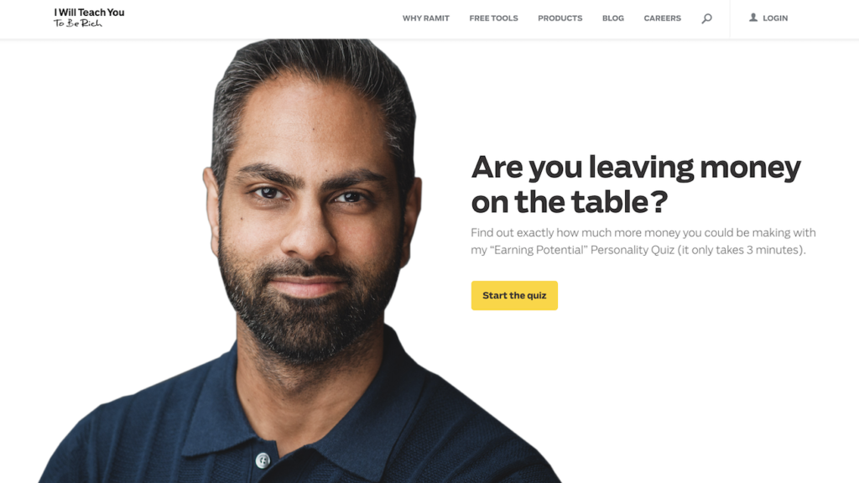
Visual structure:
- Headline in Cedar Green
- Subhead in Charcoal
- Gold underline or accent dot
- Real photo of Kelly / family / local Austin vibe
- Button: “Get a Fair Offer” (dark green, calm confidence)
Emotion it creates:
“These are real people. I trust them.”

Seller / Investor Split Section
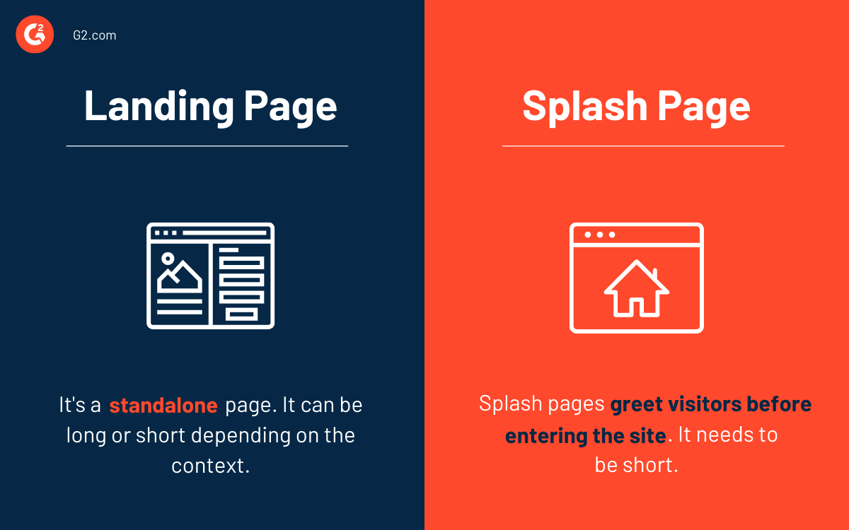

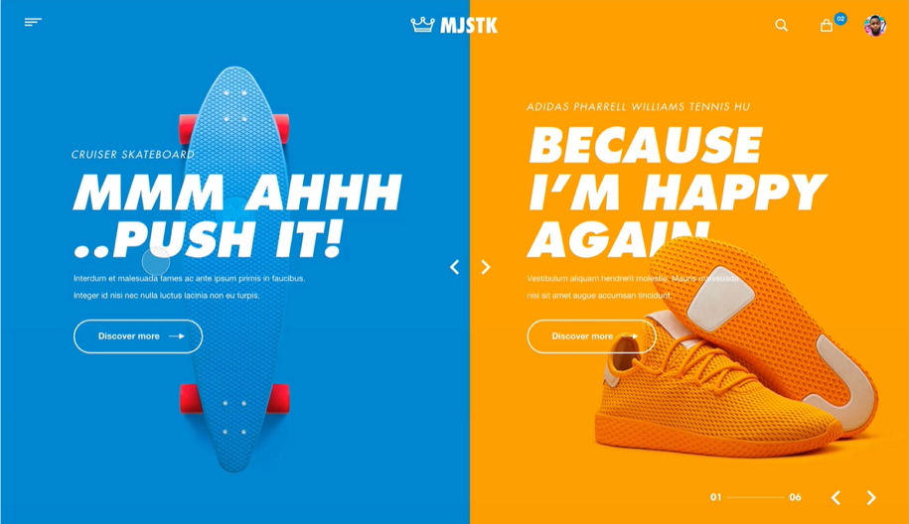
Two soft cards on a sand background:
- Seller Card
  - Soft beige background
  - Icon in gold
  - “Sell Your Home” CTA
- Investor Card
  - Same style
  - “Get Deal Alerts” CTA
This feels clear and calm, not salesy.

Deal Cards / Investor Section
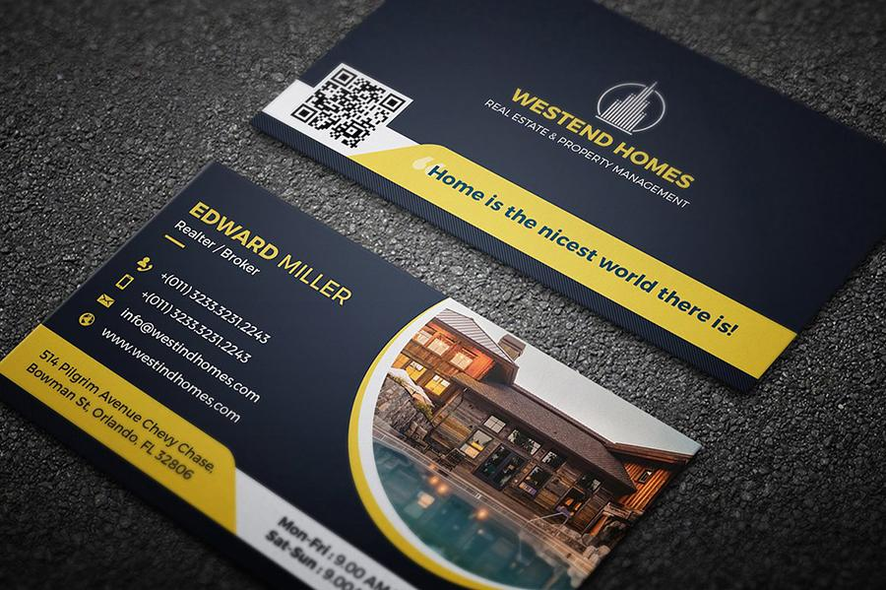
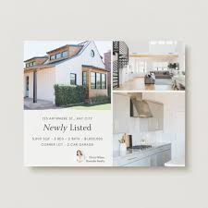
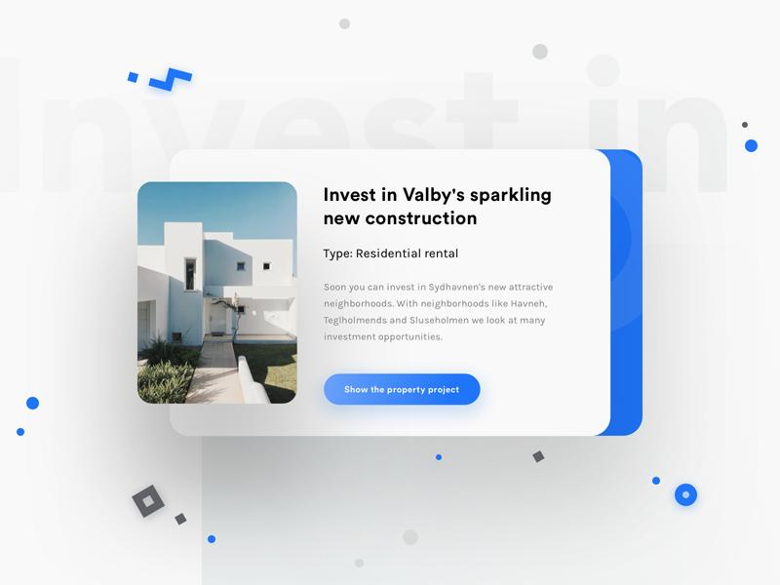
Each deal card would look like:
- Sand background
- Thin border
- Green headings
- Gold accent line
- Clean numbers (ROI, ARV, price)
Feels like:
“This is organized. Someone competent built this.”

Footer (Trust + Closure)
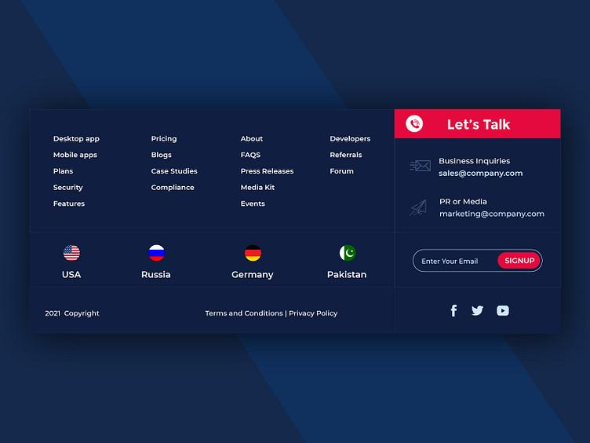
- Background: Navy Ink
- Text: Cream
- Small gold accents
- Simple, quiet confidence
- Legal + contact info visible

4) Typography — What It Actually Looks Like

Friendly-Professional Font Feel
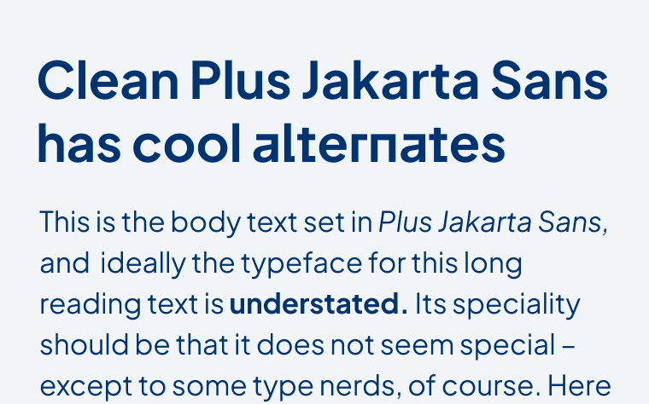
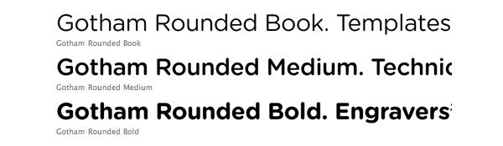
This typography combo:
- Does not feel corporate
- Does not feel startup-hype
- Does feel trustworthy and human
Exactly what you described:
professional, but friendly
serious, but warm

5) Emotional Gut Check (Most Important Part)
If a distressed homeowner lands here, they should feel:
“I’m safe. These people will treat me fairly.”
If an investor lands here, they should feel:
“These people are organized and credible.”
If either feels rushed, flashy, or confused — the brand has failed.
This palette + layout direction avoids that completely.

Next (Optional, High-Leverage)
If you want, next I can:
- Generate a visual wireframe mockup (section-by-section)
- Output CSS variables using these exact colors
- Design Seller vs Investor landing copy that matches this tone
- Create a logo direction sketch prompt for a designer or AI tool
Just tell me which one you want to see next.

